Survey of Support for PRT Loop (BART Circulator)

The Milpitas City Council needs to see public support for a pioneering transit project. Specifically, the Sunnyhills Neighborhood Association is calling for an advanced-transit loop to connect areas around the BART transit hub. Using Personal Rapid Transit (PRT) technology (small light-weight cabs and guideways, electric drive, off-line stations, and computer control), the project is expected to cost less than $50M - about the cost of building City Hall with today's dollars.
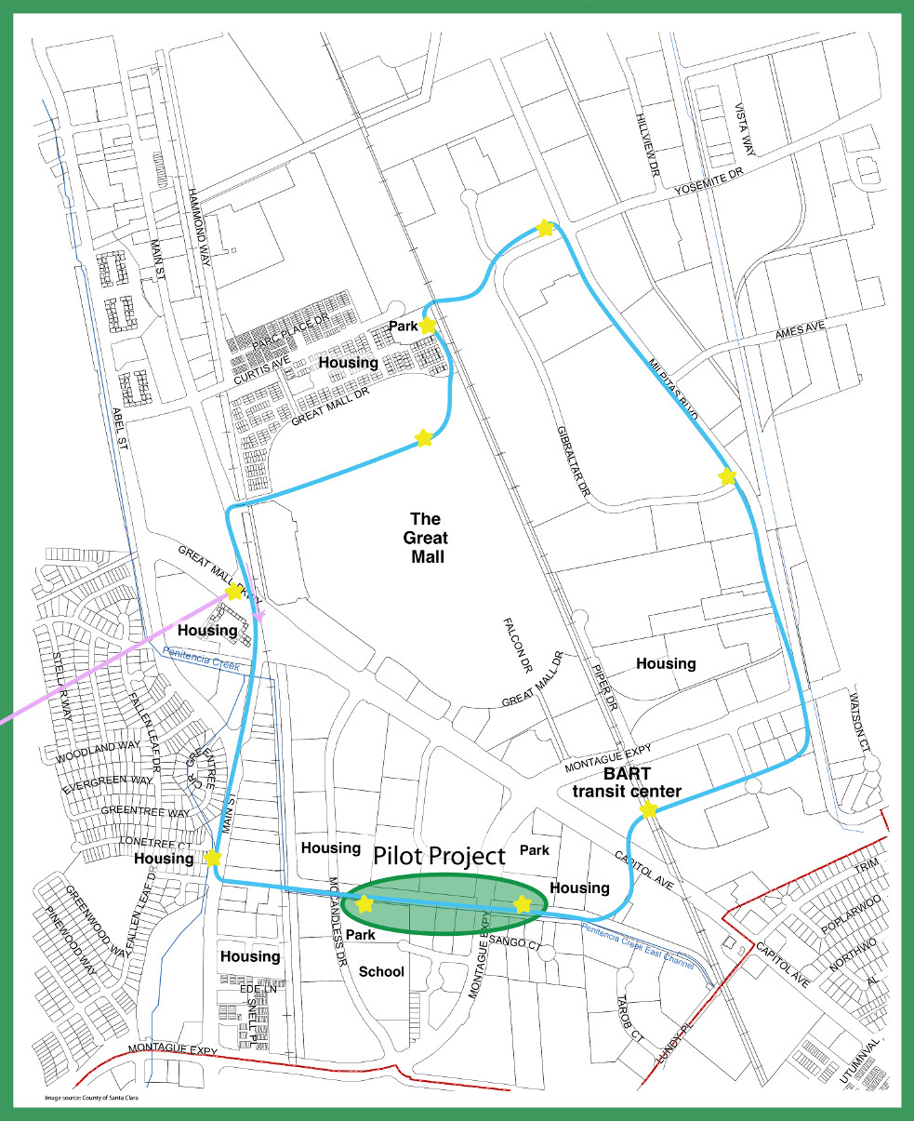
For those who live in the area of the PRT Loop, it will provide elevated mobility to cross 5 major barriers and connect 7 housing areas with two parks, the new school, Great Mall, and transit hub (BART, LRT, bus station). Although traffic congestion is already bad, more people and traffic are expected as several thousand more residents move in and 12,000 people ride BART daily. Currently, bicycle and pedestrian mobility is thwarted by 2 major roads (Montague Expy. and Great Mall Pkwy.), 2 sets of railroad tracks, and a creek that segment the area. Building an elevated PRT Loop will ease travel for all who enter the Transit Area. Before starting the PRT Loop, we can build a two-station PRT Pilot Project that demonstrates the technology.

Milpitas residents living outside the Transit Area could benefit from a long-term plan to expand the system. As additional loops are added, all Milpitas residents could benefit from a PRT network that provides quick and easy access to the transit hub.

I support PRT. I call upon the Milpitas City Council to put a PRT Pilot Project into the Capital Improvement Program so it can qualify for outside funding.

Name (print clearly): _______________________________________________________

□ I would use this type of transit. □ Someone else in my household would use it.
How often? ________________ How often? _____________________

What do you like or find attractive about a PRT Loop? ________________________________

Would you allow your child to use PRT for non-stop, origin-to-destination transit to school? Yes/No/Maybe _________

I will also contribute □ time, □ money, or □ both. Contact me here for that purpose:

____________________________________________________________________________
(USPS address, e-mail address, or phone/text #)

Any money contributed will go to the Environmental Impact Report (EIR) fund that the Sunnyhills Neighborhood Association (a 501c3 non-profit) is accumulating. As a contributor, your name will be listed on our website; if you prefer to be listed as “Anonymous”, please check here □ . Learn more at http://sunnyhillsneighborhood.org/crossing.html

Return form to: SNA, 1421 Yellowstone Ave., Milpitas, CA 95035-6913 or
e-mail to info@SunnyhillsNeighborhood.org (Contact: Rob Means, 408-262-0420)

